Assignment 2: Colours (40 : 2 = 20 marks)
Name: …
Class: …
1 INTRODUCTION
A website is like a combination of clothes. If the colours don’t match, it’s hopeless. The basic rule for webdesign is that you may not use more than four basic colours and only three colours is even better. Make also sure that your text can be read so for instance don’t put a yellow font on a white background.

2 ESTHETICS (16 marks)
Esthetics is the study of what is beautiful. Although beauty is a matter of personal taste, most people agree about what they really find ugly. Obviously you have trends in colours which are popular or not.
Judge the design of the next websites.
a.) Put a cross next to your opinion about the site. Choose from Awesome, More than ok, Ok or Eow!.
b.) Defend your choice with one argument.
Te beoordelen sites | Oordeel
http://www.vhti.be/  ARGUMENT: … | Awesome  More than ok  Ok  Eow!
http://www.dendermonde.be/  ARGUMENT: … | Awesome  More than ok  Ok  Eow!
http://www.wibra.be  ARGUMENT: … | Awesome  More than ok  Ok  Eow!
http://www.thermaepalace.be/  ARGUMENT: … | Awesome  More than ok  Ok  Eow!
http://www.architect-vanseveren.be/  ARGUMENT: … | Awesome  More than ok  Ok  Eow!
http://nl.wikipedia.org/wiki/Hoofdpagina  ARGUMENT: … | Awesome  More than ok  Ok  Eow!
http://www.uniqlo.jp/uniqlock/  ARGUMENT: … | Awesome  More than ok  Ok  Eow!
http://www.futuretainment.com/  ARGUMENT: … | Awesome  More than ok  Ok  Eow!

3 THE STUDY OF COLOURS (4 marks)
Every colour and even a combination of colours can have a certain meaning. These meanings differ from culture to culture. Black for instance is the colour of mourning at ours whereas white has that function in China. Use Wikipedia to give the exact scientific name for the asked colours.
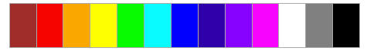
Give the correct name for the next colours:
• 6th colour: …
• 8th colour: …
• 9th colour: …
• 10th colour: …
Many scientists have looked for systems to order colours. Itten developed the next system.
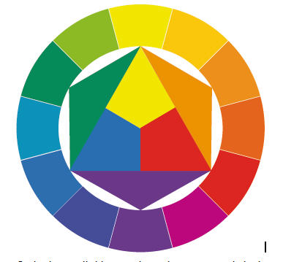
This colour scheme of Itten can help you to combine the right colours:
1. Avoid combining pure colours (inner triangle) unless you are making a site for very young children.
2. Combine the colours from the external ring and which are close to each other, especially in the combination with white.
4. Avoid combining pure yellow, pure red or pure blue, unless you make a site for discounts.
5. A site will look more sophisticated if you don’t use the pure colours from the Itten system. Go for colours which have been derived from these basic colours but make sure that they have a common ancestor in the Itten system.

4 FINAL TEST (20 marks)
If you don’t feel colours, use the next sites to help you:
- http://colorblender.com/: The site will give you the matching colours for any colour.
- http://www.colourlovers.com/: A collection of colour combinations which are ready to be used.
- http://kuler.adobe.com/#themes/rating?time=30: The same as above but a description of the atmosphere has been included.
Test 1: Your taste
Fill the cells of the table with colours which match. To fill a cell with a colour: select the cell (go with the cursor to the left side of a cell and click with the left mouse button when the arrow is black). Then click on the right mouse button. Then click on Randen en Arcering. Go the third TAB page which is called Arcering. You can choose a colour now. If you click on Meer kleuren, you can select more different colours.
Assessment by the teacher:
Eow! | Unfit | Ok | Good | Wow!

Test 2: Combine with the given colour.
Assessment by the teacher:
Eow! | Unfit | Ok | Good | Wow!

Test3: Make a colour combination for the site of an expensive lawyers’ office.
Assessment by the teacher:
Eow! | Unfit | Ok | Good | Wow!

Test 4: Make a bright colour combination for a kindergarten.
Assessment by the teacher:
Eow! | Unfit | Ok | Good | Wow!

Test 5: Make a colour combination for a clan site of a online game like League of Legends.
Assessment by the teacher:
Eow! | Unfit | Ok | Good | Wow!

